1. What is markup language

standard text-encoding system consisting of a set of symbols inserted in a text document to control its structure, formatting, or the relationship between its parts.

Markup is specifically used to label parts of the document for what they are, rather than how they should be processed

Example : html , xml

1. What kind of language is javascript

JavaScript (often shortened to JS) is a lightweight, interpreted, object-oriented language with first-class functions, and is best known as the scripting language for Web pages. JavaScript is a text-based programming language used both on the client-side and server-side that allows you to make web pages interactive.

1. How do you insert moving text ?

The <marquee> tag in HTML is used to create scrolling text or image in a webpages. It scrolls either from horizontally left to right or right to left, or vertically top to bottom or bottom to top.

1. Is javascript compiled or interpreted?

JavaScript is an interpreted language, not a compiled language. A program such as C++ or Java needs to be compiled before it is run. ... Instead, an interpreter in the browser reads over the JavaScript code, interprets each line, and runs it.

1. which company developed js

Brendan Eich, a Netscape Communications Corporation programmer, created JavaScript in September 1995.

1. what is the use of "this"

this keyword refers to an object, that object which is executing the current bit of javascript code. In other words, every javascript function while executing has a reference to its current execution context, called this.

1. Advantages and disadvantages of js

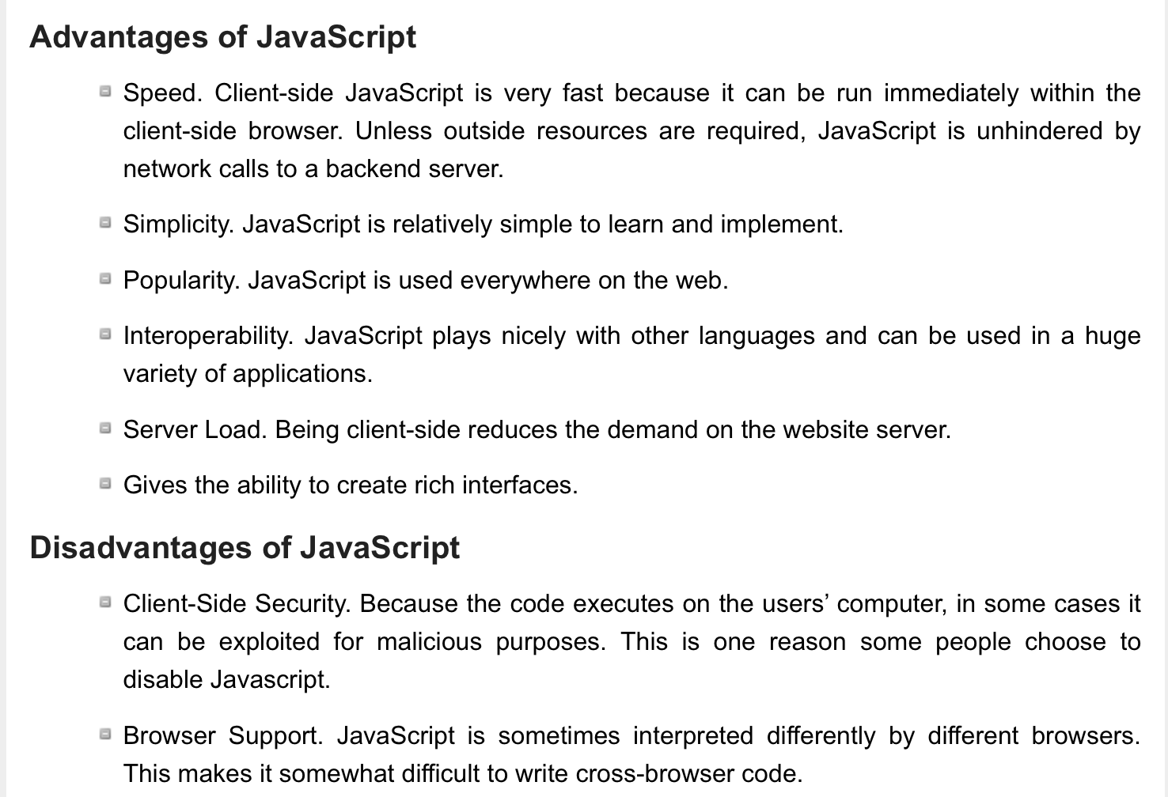

1. hr tag is used for?

The <hr> tag in HTML stands for horizontal rule and is used to insert a horizontal rule or a thematic break in an HTML page to divide or separate document sections. The <hr> tag is an empty tag, and it does not require an end tag.

1. Abbr tag

The <abbr> tag(Abbreviation) in HTML is used to define the abbreviation or short form of an element

<abbr title=""> Short form </abbr>

* [title](https://www.geeksforgeeks.org/html-title-attribute/): It is used to specify extra information about the element. When the mouse moves over the element then it shows the information.

1. How will u insert music and it's attributes

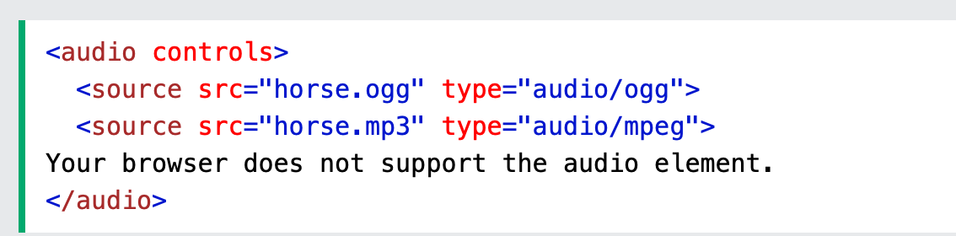

Controls add play , pause , like that functionalities

1. Which layer is ftp

File Transfer Protocol(FTP) is an application layer protocol which moves files between local and remote file systems

1. Iframe tag

The <iframe> tag specifies an inline frame. An inline frame is used to embed another document within the current HTML document.

Iframe is basically used to show a webpage inside the current web page.

1. Who is father of internet

Vint Cerf is considered to be one of the fathers of the internet,

1. what is domain name for india

It is the Internet country code top-level domain (ccTLD) for India.

1. Which protocol is used in gmail

The IMAP email protocol stores all mail messages and email folders on the server, so that any changes made when you access Gmail on one device also show on any other device used to check your Gmail emails

1. What is meant by .com in urls

Com is one of hundreds of top-level domains. The .com at the end of many web addresses (such as Lifewire.com) is called a top-level domain (TLD).

1. Which side (client or server) js is used mostly and why

Client side for more interactiveness

1. Url used for

URL stands for Uniform Resource Locator, and is used to specify addresses on the World Wide Web. A URL is the fundamental network identification for any resource connected to the web

1. who manages www

The World Wide Web Consortium (W3C) is an international community where Member organizations, a full-time staff, and the public work together to develop Web standards. Led by Web inventor and Director Tim Berners-Lee and CEO Jeffrey Jaffe, W3C's mission is to lead the Web to its full potential.

1. Script tags

The <script> tag is used to embed a client-side script (JavaScript). The <script> element either contains scripting statements, or it points to an external script file through the src attribute.

1. How do you measure speed of modem speed

Internet speed is measured in bits per second, or bps. Traditional dial-up modems have typically offered an Internet speed of 64 kilobits per second (Kbps), or 64 thousand bps.

1. Javascript client side or server side

Client-side means that the JavaScript code is run on the client machine, which is the browser. Server-side JavaScript means that the code is run on the server which is serving web pages. One runs in the browser (client side), the other runs on the server.

1. What is use of post method

POST is a request method supported by HTTP used by the World Wide Web. POST request method requests that a web server accepts the data enclosed in the body of the request message, most likely for storing it. It is often used when uploading a file or when submitting a completed web form.

1. Concatenation in JS

The JavaScript concat() **method merges the contents of two or more strings**. You can also use the + concatenation operator to merge multiple strings. The concatenation operator is preferred in most cases as it is more concise. Concatenation is a technique used in programming to merge two or more strings into one value.

1. Advantage of css

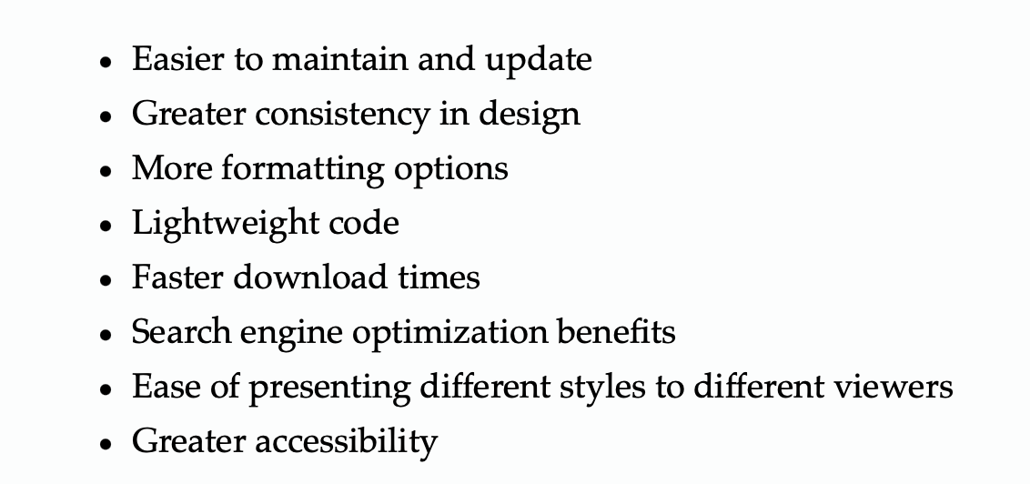

1. difference between markup language and programming language

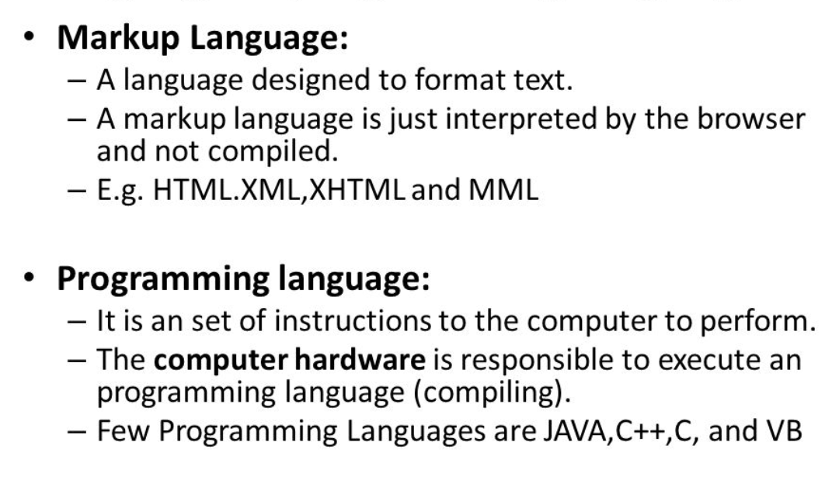

1. what is "client side scripting"

A client-side script is a program that is processed within the client browser. These kinds of scripts are small programs which are downloaded , compiled and run by the browser. **JavaScript** is an important client-side scripting language and widely used in dynamic websites.

1. How to maintain crct horz and vertical space

By using padding and margin

1. print hello world using js

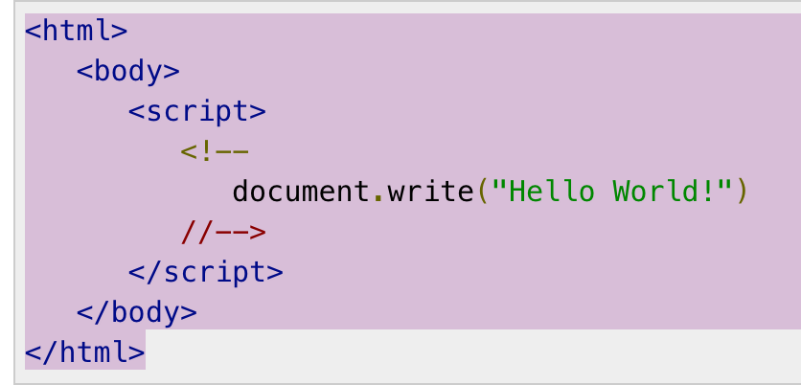

1. tt tag

The <tt> tag is the abbreviation of **teletype text**. This tag is depreciated from HTML 5. It was used for marking Keyboard input. It was mainly used for formatting purposes

1. What is css

CSS stands for **Cascading Style Sheets**. It is the language for describing the presentation of Web pages, including colours, layout, and fonts, thus making our web pages presentable to the users. ... It is independent of HTML and can be used with any XML-based markup language.

1. What is font , font alignment

A font is **a collection of characters with a similar design**. These characters include lowercase and uppercase letters, numbers, punctuation marks, and symbols. Changing the font can alter the look and feel of a block of text.

Text alignment is **a paragraph formatting attribute that determines the appearance of the text in a whole paragraph**. For example, in a paragraph that is left-aligned (the most common alignment), text is aligned with the left margin. In a paragraph that is justified, text is aligned with both margins.

1. Who is the primary author of html- The primary Author of HTML is Tim Berners-Lee, a scientist and academic, with the assistance of his colleagues at CERN, an international scientific …
2. list any event handler -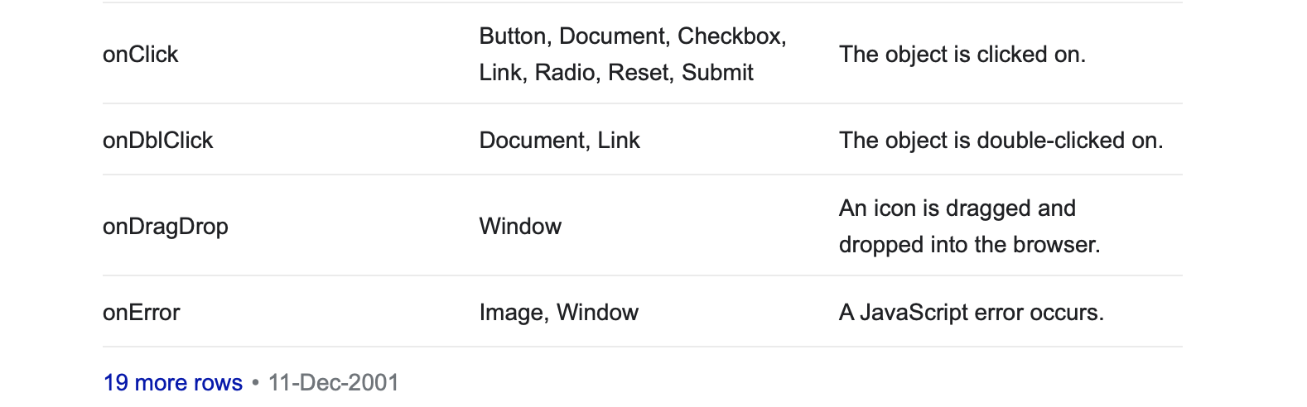
3. what is meta tag

Meta tags provide information about the webpage in the HTML of the document. This information is called "metadata" and while it is not displayed on the page itself, it can be read by search engines and web crawlers. ... Example of meta tags include **the <title> and <description> elements.**

1. What html doesn't need closing tags

<img.../>, <hr /> and <br />, <input /> elements. These are known as void elements.

1. How do you insert an image?

<img src=”(your image URL here)” alt=””>

1. What's extension of html file , can we use .htm as extension ?

This extension is either . htm OR . html

1. Name one photo editing software ?

Adobe photoshop , canva

1. Which tag is used to write paragraph ?

The <p> HTML element represents a paragraph.

1. Unordered list ?

An unordered list typically is a bulleted list of items, starting tag <ul>

Ordered list <ol> - a numbered list of items.

1. Table ?

To create table in HTML, use the <table> tag. A table consist of rows and columns, which can be set using one or more <tr>, <th>, and <td> elements. A table row is defined by the <tr> tag. To set table header, use the <th> tag. Td is each cell in the table

1. Br is used for

the <br> HTML element produces a line break in text

1. Href use

<a> tag is used to link from one html page to other in which href Attribute is used to specify the URL of the page that the link goes to

1. Multimedia elements

There are five basic elements of multimedia: text, images, audio, video and animation.

1. What software you need to work on a html file

If you prefer to code HTML by hand, you can use a simple text editor to create web pages. Adobe also available

1. Comment in html

**<!** **--- and --->**

1. Spacing - &nbsp; (non-breaking space)
2. Who manages javascript currently

Oracle Corporation Brebden eich netspace communications and company

1. Functions in js

A function in JavaScript is similar to a procedure—a set of statements that performs a task or calculates a value, but for a procedure to qualify as a function, it should take some input and return an output where there is some obvious relationship between the input and the output.

1. Pop up in js

The **pop** method removes the last element from an array and returns that value to the caller. **pop** is intentionally generic; this method can be called or applied to objects resembling arrays.

1. what is the use of "alt" in img tag

The ALT text **adds a text description to an image on a Web page**, and should be used for all images, graphical bullets, and graphical horizontal rules.

1. Html case sensitive or case insensitive

**HTML is case insensitive in most respects**, except when it comes to certain attribute values, like the id and class attributes. XHTML, being XML, is always case sensitive.

1. Formating tags in html

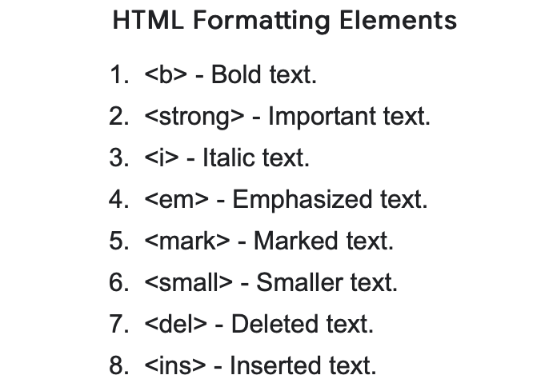

1. Primary tag in html

There are four required tags in HTML. These are html, **title, head and body**.

1. Title tag

The <title> tag defines the title of the document. The title must be text-only, and it is shown in the browser's title bar or in the page's tab.

1. What is head tag

The <head> tag in HTML is **used to define the head portion of the document which contains information related to the document**.

1. What are tags in html

HTML tags are like keywords which defines that how web browser will format and display the content

1. Root tag

The **<html> HTML** element represents the root (top-level element) of an HTML document, so it is also referred to as the root element. All other elements must be descendants of this element

1. onmouseover tag?- The onmouseover attribute **fires when the mouse pointer moves over an element**. Tip: The onmouseover attribute is often used together with the onmouseout attribute.
2. how to declare variables in javascript

Use **the reserved keyword var** to declare a variable in JavaScript. Syntax: var <variable-name>; var <variable-name> = <value>; A variable must have a unique name.

1. How will u use a script tag for javascript

used to embed executable code or data;

* <script type="text/javascript">
* How do you link a script from an external file?

<script type="text/javascript" src="xxx.js">

1. Can we write js code in headtag? / where should we write the js code ?

JavaScript in body or head: Scripts can be placed inside the body or the head section of an HTML page or inside both head and body.

1. What is min and max font size ?

Default is 3 and largest is 7 vw (viewport width )

1. Class b address range?

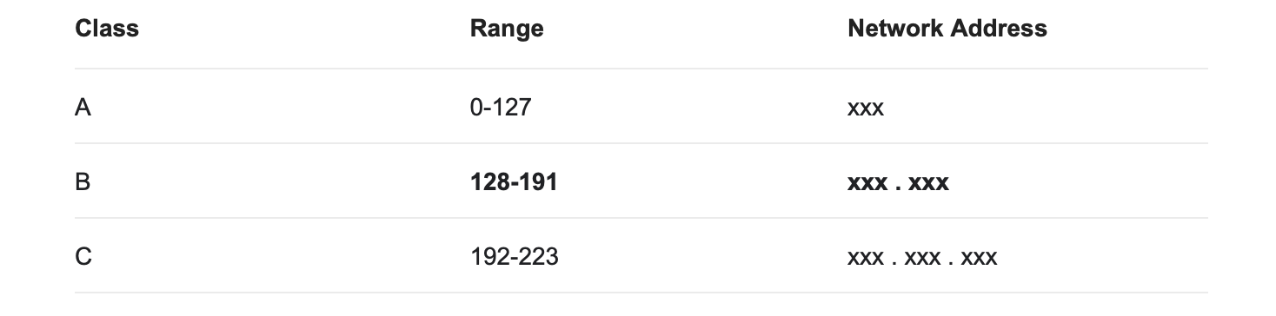

1. what is dns server

The Domain Name System (DNS) is an important part of the internet, providing a way to map names (a website you're seeking) to numbers (the address for the website).